NATIONAL UNIVERSITY OF MODERN LANGUAGE ISLAMABAD
Open Ended lab


Submitted to:
Mr. Danish
Submitted by:
Zulqarnain Hassan
Roll No: …………………… SP21379
Subject: …………………… WEB II
Department: ……………… BSSE-7-Afternoon
Date: ……………………… 23-12-2026

Task 1: Dynamic Data Loading & Pagination

data.jsx

export const fetchCourses = (page, limit = 20) => {
return new Promise((resolve) => {
// Simulating AJAX delay
setTimeout(() => {
const allCourses = Array.from({ length: 200 }, (_, i) => ({
id: i + 1,
title: `Course ${i + 1}: ${['Web Dev', 'Data Science', 'UI/UX', 'Cloud'][i % 4]}`,
instructor: `Instructor ${String.fromCharCode(65 + (i % 26))}`,
}));

const start = (page - 1) * limit;
const end = start + limit;
resolve({
data: allCourses.slice(start, end),
total: allCourses.length
});
}, 500);
});
};

app.jsx
import { useState, useEffect } from 'react';
import { fetchCourses } from './data';

function App() {
const [courses, setCourses] = useState([]);
const [currentPage, setCurrentPage] = useState(1);
const [loading, setLoading] = useState(false);
const totalPages = 10; // 200 total / 20 per page

useEffect(() => {
loadPage(currentPage);
}, [currentPage]);

const loadPage = async (page) => {
setLoading(true);
const result = await fetchCourses(page);
setCourses(result.data);
setLoading(false);
};

return (
<div style={{ padding: '20px', fontFamily: 'sans-serif' }}>
<h1>Admin Dashboard: Courses</h1>

{loading ? <p>Loading courses...</p> : (
<ul>
{courses.map(course => (
<li key={course.id}>{course.title} - <em>{course.instructor}</em></li>
))}
</ul>
)}

<div style={{ marginTop: '20px' }}>
{Array.from({ length: totalPages }, (_, i) => (
<button
key={i + 1}
onClick={() => setCurrentPage(i + 1)}
style={{ margin: '2px', fontWeight: currentPage === i + 1 ? 'bold' : 'normal' }}
>
{i + 1}
</button>
))}
</div>
</div>
);
}

export default App;

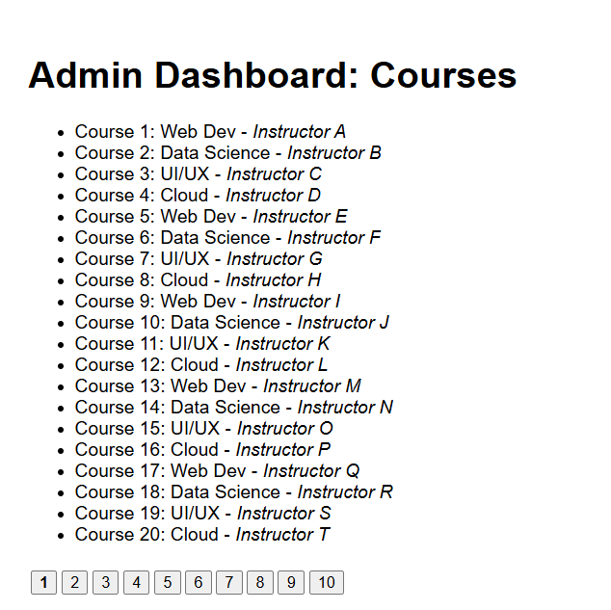
Task 2: Real-Time Participant Management
Utilize React state management to model a participant enrollment module where the administrator can:
Add new participants to a selected course using a form
Mark participants as active/inactive using a toggle or checkbox
Remove participants who withdraw from the course
Ensure that all updates are reflected immediately in the UI using state-based rendering.
ParticipantManager.jsx

import { useState } from "react";

function ParticipantManager() {
const [participants, setParticipants] = useState([]);
const [name, setName] = useState("");

const addParticipant = () => {
if (!name) return;

setParticipants([
...participants,
{ id: Date.now(), name, active: true }
]);

setName("");
};

const toggleStatus = (id) => {
setParticipants(
participants.map(p =>
p.id === id ? { ...p, active: !p.active } : p
)
);
};

const removeParticipant = (id) => {
setParticipants(participants.filter(p => p.id !== id));
};

return (
<div>
<h2>Participants</h2>

<input
type="text"
placeholder="Participant name"
value={name}
onChange={(e) => setName(e.target.value)}
/>
<button onClick={addParticipant}>Add</button>

<ul>
{participants.map(p => (
<li key={p.id}>
{p.name} — {p.active ? "Active" : "Inactive"}

<input
type="checkbox"
checked={p.active}
onChange={() => toggleStatus(p.id)}
/>

<button onClick={() => removeParticipant(p.id)}>Remove</button>
</li>
))}
</ul>
</div>
);
}

export default ParticipantManager;

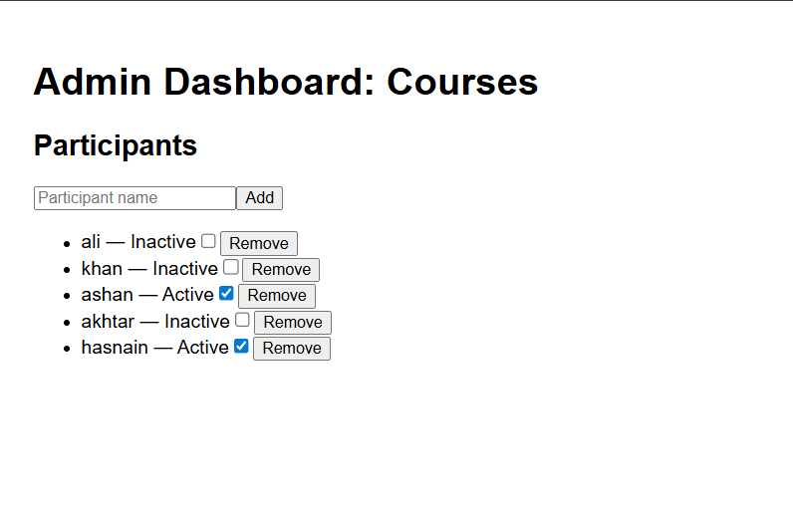
Task 3: Integration & Application Logic
Build the overall flow by combining AJAX-based pagination and state-driven UI updates, demonstrating how frontend logic can efficiently manage large datasets and real-time user interactions in a single web application.
app.jsx updated

import { useState, useEffect } from 'react';
import { fetchCourses } from './conponents/data';
import ParticipantManager from './conponents/ParticipantManager';

function App() {
const [courses, setCourses] = useState([]);
const [currentPage, setCurrentPage] = useState(1);
const [selectedCourse, setSelectedCourse] = useState(null);
const [loading, setLoading] = useState(false);

useEffect(() => {
const loadData = async () => {
setLoading(true);
const result = await fetchCourses(currentPage);
setCourses(result.data);
setLoading(false);
};
loadData();
}, [currentPage]);

return (
<div style={{ display: 'flex', gap: '40px', padding: '20px' }}>
{/* Sidebar: Course Listing (Task 1) */}
<div style={{ flex: 1 }}>
<h2>Courses</h2>
{loading ? <p>Loading...</p> : (
<div>
{courses.map(c => (
<li
key={c.id}
onClick={() => setSelectedCourse(c)}
style={{
padding: '0px',
cursor: 'pointer',
background: selectedCourse?.id === c.id ? '#e0e0e0' : 'white',
borderBottom: '1px solid #eee'
}}
>
{c.title}
</li>
))}
</div>
)}
{/* Pagination Controls */}
<div style={{ marginTop: '10px' }}>
{[1, 2, 3, 4, 5].map(n => (
<button key={n} onClick={() => setCurrentPage(n)}>{n}</button>
))}
</div>
</div>

{/* Main Content: Participant Management (Task 2) */}
<div style={{ flex: 2 }}>
{selectedCourse ? (
<>
<h2>Editing: {selectedCourse.title}</h2>
<ParticipantManager />
</>
) : (
<p>Select a course to manage participants</p>
)}
</div>
</div>
);
}

export default App;

